Project Proposal

**E-mu.**

The music app based on your emotions.

Hand-in Date: 22nd January 2016

Jamie Millman

Student number: 12814408

CI360 – Mobile Application Development

School of Computing, Engineering and Mathematics

# 1) Elevator pitch

For my mobile application I have decided to create a music app that works with the users emotions. The user will be asked to choose an emotion that they want to be feeling. This means they will choose whether they want to be consumed by their current emotion, try and get away from it or just feel a different emotion from what they currently are. Depending on the choice they make it will affect the music that is played for them.

# 2) Rationale

Music evokes emotions in everyone. Perceived emotions and felt emotions are two different types of emotions related to music.[1] Everyone in the world feels these emotions when listening to music, however the emotions that music invokes is different for everyone. Music can be used to: calm someone down, pump someone up, make someone sad, make someone happy and even make someone angry. With this app I will be working with those emotions to hand pick songs and create playlists that will either prevent or encourage individuals to succumb to those emotions. The target audience for this app will be aged 16-54 both male and female. The reason I have chosen this target audience is statistics show[2] in the UK the percentage of mobile phone usage drops dramatically when the user is aged 55+. Although this is my target audience the app will be aimed at all ages. The reason for this is because music affects everyone’s emotions, no matter your age. The only restriction stopping people aged 55+ is the usage of their mobile device.

# 3) Application

The application I am creating will allow users to choose an emotion they would like to be feeling. This emotion can be chosen to increase the current emotional state they are in. It can be used to try and get away from that emotion or they could simply just want to feel another emotion entirely. This application will allow a user to make that decision. After the decision is made they will get presented with a playlist of music correlating with their chosen emotion. The user will only be able to see the current song playing. The user will then be able to: skip, pause, play and rate the song they are currently listening to. The user will be able to rate the song with a star rating system. This will log the information for me to check what songs are working and what ones are not. This will be used in the future to improve my application; it will help hone the music I use for each emotion. Seeing what ones work better than others on a quantitative scale. I want my application to have no sign up or login to load it. I want new users to be able to quickly log in and start using the application without having to previously sign up.

Before deciding on this application I researched various other music apps that focused on emotions to see what my competition was and how I can adapt mine to be unique.

**Songza**

The first application that I analysed was Songza. Songza is a very popular music application that plays music according to the typical activities users partake in every day. For example if the user was to load up the application on a Monday morning it will give that user a list of typical morning activities that they can select from, for example: waking up happy, waking up gently, working out, driving and many more.

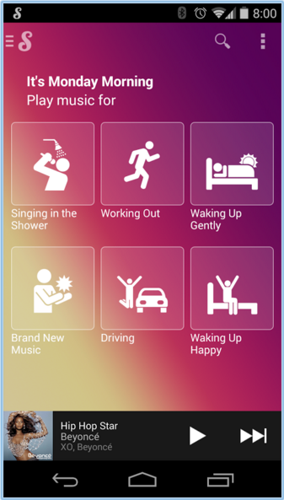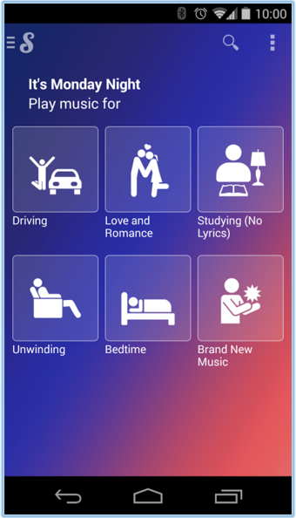

This is similar to my application in the sense that it allows the user to make a choice of the type of music they want to listen to. They precompile a large amount of playlists with various types of music genres within them. They then get the user to make a decision that is far simpler than choosing a music genre to listen to, they allow them to choose the activity that they are currently doing. This is very appealing for a user because not much thought needs to go into their decision, resulting in an effortless task to acquire relevant music. Of course this is quite general because it takes out emotion from most categories, for example some users might want to relax in their morning shower listening to classical music as apposed to someone who wants to get pumped up in the shower with electronic music.

From viewing this application I narrowed my focus to music based primarily off emotions. It made me realise that everyone’s taste is different so catering for everyone will be hard. This is why I am going to be doing quantitative research into what genres of music people link to each emotion. Then create my playlists based on those results.[3]

**Stereomood**

Stereomood was an application that unfortunately had to shut down due to funding issues. It was an application that filtered music with emotions, activities and general moods. Although it is not a current competitor of my application, I felt it was necessary to mention this application because it helped me understand the route to take with my app. Stereomood focused on using playlists to group songs together. The user was able to pick from a large amount of ‘moods’ to then receive a corresponding playlist. The moods were a mix of emotions, activities, scenarios and genres. For example: Cool, Dancing asleep on my feet, funky, it’s raining and many more.

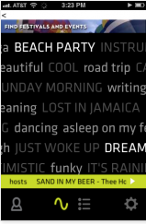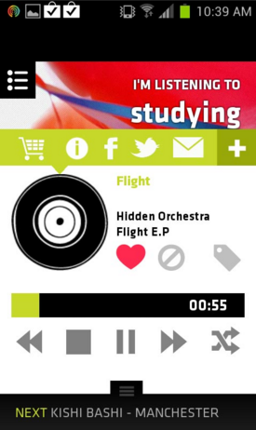

This makes the application very large, giving the user a lot of options to choose from. From viewing this application I decided to make my design and user experience a lot more minimalistic and simple. This will reduce the amount of thinking the user will do to receive the type of music they want to be listening to.[4]  
  
From analysing these two applications I gained a lot of insight into what users like and dislike about music applications that focus on the users interaction. I will be able to harness the knowledge gained from researching these two apps to create a successful emotion based music application.

# 4) Scenario of use

I have created a scenario to show how and why my application will get used in context.

“Sarah was riding a very busy underground train to work in London. She was very tired and found herself getting very angry at the amount of noise and commotion happening on the 8:30am train. She wanted to calm herself down as quickly as possible. Sarah plugged her headphones into her mobile phone and opened “E-mu. The music app based on your emotions”. She gets asked by the application “What emotion would you like to be feeling?”she swiped until she got to the emotion “calm”. She clicked onto the emotion and calming music instantly began to play. She started to feel more relaxed, changing her train journey from loud and angry to soothing and relaxing.”

# 5) Technical overview

I will be using Cordova Phonegap to develop my application. The application will be written in HTML, CSS, JavaScript, JQuery, PHP and JSON. JSON will be used for calling the items from the API/SDK. The application will have 5-10 screens when first loaded. These screens will consist of the emotions the user would want to feel and the landing screen. Each one will be a full colour background with the single word emotion in large typography. The user will be able to navigate through them by swiping the screen left or right (it will prompt the user to do so). This will all be created with HTML, CSS and JavaScript/JQuery. The user will then select one of the emotions. This will call the information from the Deezer website playlists by selecting the JSON created through the SDK. This will be selected and retrieved by using the document object model.

For my application I will need to have access to a library of songs that I will be able to put into playlists that represent emotions the user wants to feel, such as: angry, calm, scared etc. To do this I would need to have a music application API/SDK (Application Program Interface/Software Development Kit) that allows free streaming of music. At first I looked at the music software 8tracks[5], which is a music application that plays music primarily through playlists. Users create their own playlists and share them globally, they then get rated and displayed dependant on the overall rating. However 8tracks have stopped issuing API keys since February 2015[6]. I then found the app Deezer[7], which is a popular music application that has a free API and multiple SDK’s available to use. I will be using the Web SDK that is written in JavaScript. With this SDK I will be able to call playlists that I have previously created and get the correct one to play when a specific emotion is selected.

# 6) Technical challenges

The main technical challenge I believe to encounter during the development of my application is the implementation of the SDK, and knowing how to use specific aspects from it. Every SDK uses different variables and functions so I believe learning how to call their intricate elements into my application will be the hardest challenge of this project.

I believe linking the HTML, CSS and JavaScript/JQuery fluidly with the SDK will also prove to be challenging. The speed and synchronicity of this application is very important. I want the user experience to be pleasant and extremely fast and I believe getting it to not seem clunky and slow will be difficult, however this is key in the success of this application.

# 7) UI design draft

I have designed three screens of a single path a user could potentially take.

**Screen 1 Screen 2 Screen 3**

# Macintosh HD:Users:jamiemillman:Documents:University Stuff:Year 3:Mobile App Development:Sketches:homepage.pngMacintosh HD:Users:jamiemillman:Documents:University Stuff:Year 3:Mobile App Development:Sketches:anger emotion.pngMacintosh HD:Users:jamiemillman:Documents:University Stuff:Year 3:Mobile App Development:Sketches:playing song.png

The three screens above begin with the user on the homepage (screen 1). They are asked to choose an emotion that they would like to feel after listening to some music (all the text is very rough and expected to change dramatically). The user is then asked to swipe the screen to begin. Once the user has swiped, it will bring them to screen 2. Screen 2 is one example of the many emotions that will be on the app. Once on the anger emotion the user can choose to select this emotion, or swipe for others. If the user selects this emotion they will be shown screen 3. Screen 3 shows one of the songs from the anger playlist. The user will be able to: see the album artwork, the artist name, the album name, the song title, rate the song and skip, pause and play the current song. There is a home button located at the bottom left of the screen that will allow the user to navigate back to the emotion select screen (screen 2).

# 8) Work plan

I have created a Gantt chart to show the work needed to implement the application. In this chart it breaks the project into four groups, each group having it’s own tasks.

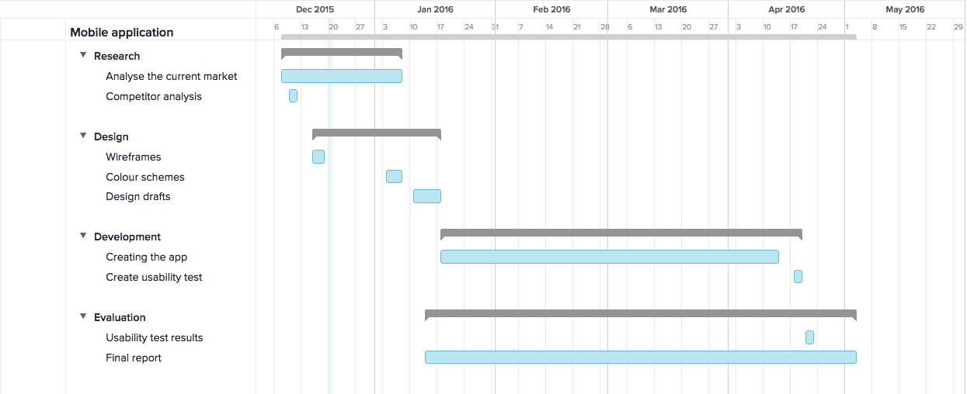

# 9) Ethical considerations

My mobile application focuses on the users emotions, however it only asks the user what emotion they would *like*to feel after listening to music. I do not believe this is ethically wrong as the app is used to assist in the user getting to this emotion, it does not ask them to act out on the emotion they are feeling.

I will be creating a usability test for 3-5 users to undertake. In this test I will ask them to preform simple tasks on my mobile application. After the tasks have been completed I will then ask the user questions about the application. By doing this I will be able to find out what users like and dislike about my application. These will be simple usability tests that help analyse the application, not the user. I will reinforce to the users that it is not testing them; it is testing the application itself.

# 10) Resources

I have created a list to show the resources I will need to carry out my mobile application development project.  
  
**Hardware**

* Android smartphone device.

**Software**

* PhoneGap framework.

**Online Services**

* Deezer Web SDK.

**People**

* 3-5 users to undertake my usability test.

**Data Sets**

* Lists of music to add into various playlists.

# References

Belle Beth Cooper. (2013). *THE SURPRISING SCIENCE BEHIND WHAT MUSIC DOES TO OUR BRAINS.* Available: http://www.fastcompany.com/3022942/work-smart/the-surprising-science-behind-what-music-does-to-our-brains. Last accessed 24th Nov 2015.

Statista. (2015). *Smartphone ownership penetration in the United Kingdom (UK) in 2012-2015, by age.* Available: http://www.statista.com/statistics/271851/smartphone-owners-in-the-united-kingdom-uk-by-age/. Last accessed 24th Nov 2015.

Songza. (2015). *Songza.* Available: https://play.google.com/store/apps/details?id=com.ad60.songza&hl=en. Last accessed 29th Nov 2015.

Andy Cush. (2012). *App Test: Can Stereomood, the Emotion-Based Playlister, Make Me Angry?.* Available: http://evolver.fm/2012/06/29/app-test-can-stereomood-the-emotion-based-playlister-make-me-angry/. Last accessed 29th Nov 2015.

8track. (2015). *Developers.* Available: https://8tracks.com/developers. Last accessed 9th December 2015.

1. Belle Beth Cooper. (2013). *THE SURPRISING SCIENCE BEHIND WHAT MUSIC DOES TO OUR BRAINS.* Available: http://www.fastcompany.com/3022942/work-smart/the-surprising-science-behind-what-music-does-to-our-brains. Last accessed 24th Nov 2015.
2. Statista. (2015). *Smartphone ownership penetration in the United Kingdom (UK) in 2012-2015, by age.* Available: http://www.statista.com/statistics/271851/smartphone-owners-in-the-united-kingdom-uk-by-age/. Last accessed 24th Nov 2015.
3. Songza. (2015). *Songza.* Available: https://play.google.com/store/apps/details?id=com.ad60.songza&hl=en. Last accessed 29th Nov 2015.
4. Andy Cush. (2012). *App Test: Can Stereomood, the Emotion-Based Playlister, Make Me Angry?.* Available: http://evolver.fm/2012/06/29/app-test-can-stereomood-the-emotion-based-playlister-make-me-angry/. Last accessed 29th Nov 2015.
5. https://8tracks.com/
6. 8track. (2015). *Developers.* Available: https://8tracks.com/developers. Last accessed 9th December 2015.
7. http://www.deezer.com/